
East West University

Department
Department of Computer Science and Engineering

Semester : spring 2021
Course Title: Electrical Circuits
Course Code: CSE209
Section: 03

Experiment No: 01
Experiment Title: Introduction to Circuit Elements and Variables

Student Name: Md. Rakibur Rahman
ID: 2019-3-60-113

Date of Performance: 10-3-2021
Date of Submission: 17-3-2021

Objectives:

- To get familiar with circuit variables (voltage and current) and circuit elements (voltage source and resistance).
- To learn how to measure dc voltage across a circuit element using a voltmeter.
- To learn how to measure dc current through a circuit element using an ammeter.
- To learn how to measure resistance of a resistor using a multimeter
- To verify Ohm’s Law.

Circuit Diagram: 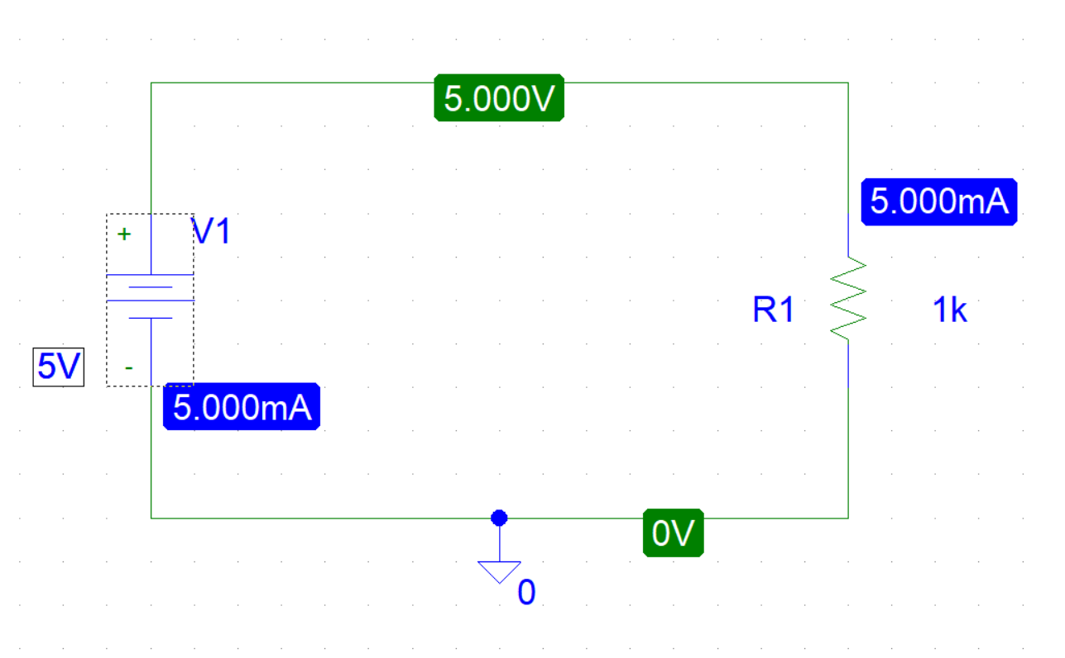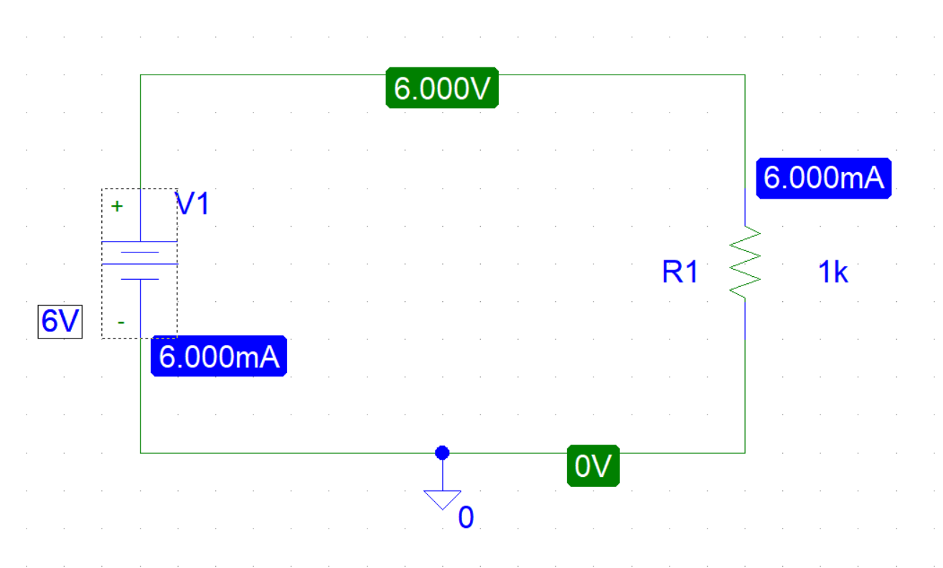

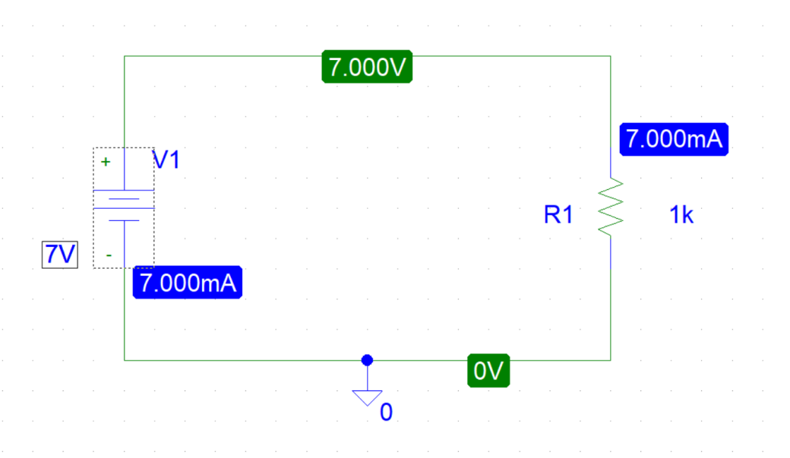

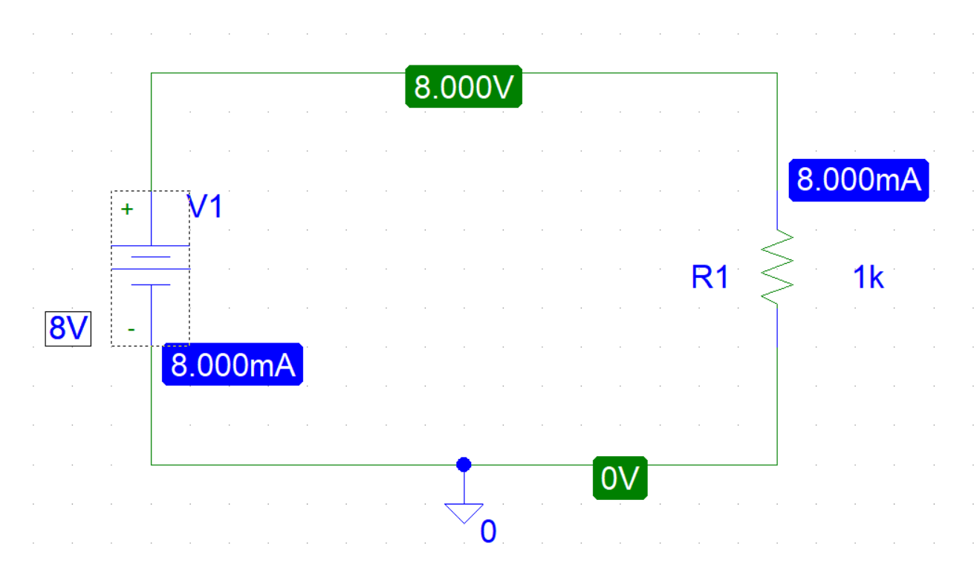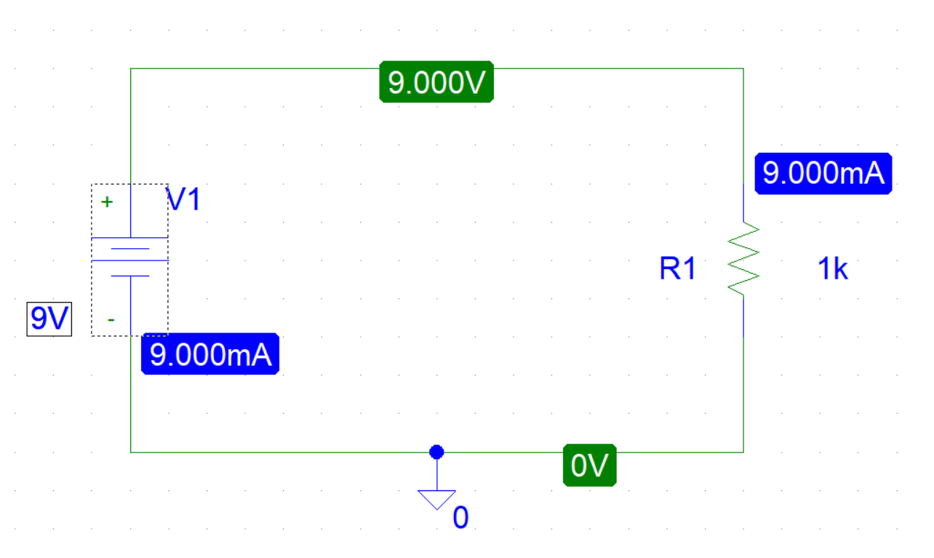
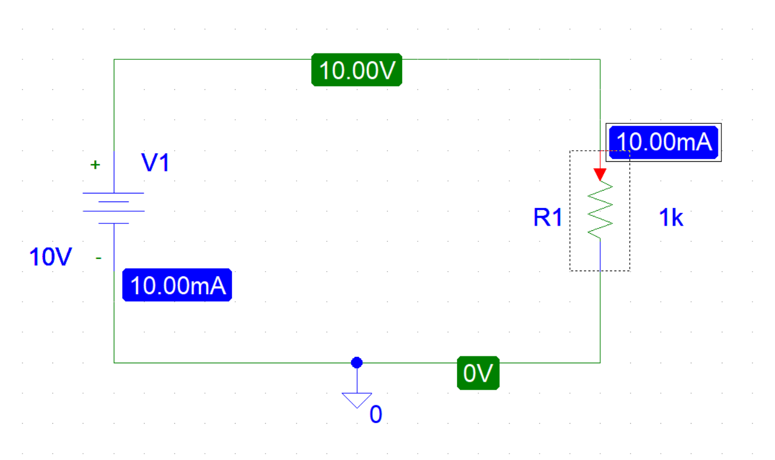

Experimental Datasheet:

Observation number | Value of voltage source E (V) | Value of R(Ω) | Measured Value of I(mA)
1 | 5 | 1000Ω | 5
2 | 6 | 1000Ω | 6
3 | 7 | 1000Ω | 7
4 | 8 | 1000Ω | 8
5 | 9 | 1000Ω | 9
6 | 10 | 1000Ω | 10

Answers to the post lab report questions:
- We have to use ohm’s law to calculate the values of I.

From ohm’s law, we know,

V = IR.

Here , given values of E=5V, 6V,7V,8V,9V,10V and R=1000 Ω

When, E=5V

I₁ =$\frac{V}{R}$ = $\frac{5}{1000}=$5mA

When, E=6V

I₂ = $\frac{V}{R}$ = $\frac{6}{1000}=$6mA

When, E=7V

I₃ = $\frac{V}{R}$ =$\frac{7}{1000}=$7mA

When, E=8V

I₄ = $\frac{V}{R}$ =$\frac{8}{1000}=$8mA

When, E=9V

I₅ = $\frac{V}{R}$ =$\frac{9}{1000}=$9mA

When, E=10V

I₆ = $\frac{V}{R}$ =$\frac{10}{1000}=$10mA

As the experiment was done in PSpice, there is no discrepancy.

- Here V₁=5V, V₂= 6V, V₃= 7V, V₄= 8V, V₅= 9V, V₆= 10V
And I₁ = 5mA, I₂= 6mA, I₃= 7mA, I₄= 8mA, I₅= 9mA, I₆= 10mA
From ohm’s law,

R₁ = $\frac{V}{I}$ =$\frac{5}{.005}=$1000$Ω$

R₂ = $\frac{V}{I}$ =$\frac{6}{.006}=$10$00Ω$

R₃ = $\frac{V}{I}$ =$\frac{7}{.007}=$1000$Ω$

R₄ = $\frac{V}{I}$ =$\frac{8}{.008}=$1000$Ω$

R₅ = $\frac{V}{I}$ =$\frac{9}{.009}=$1000$Ω$

R₆ = $\frac{V}{I}$ =$\frac{10}{.010}=$1000$Ω$

As the experiment was done in PSpice, there is no discrepancy.

- As the experiment was done in PSpice, the set values of E and the value of V are same. Thus , there is no discrepancy.

4.

5.The experiment was done in Pspice.So the multi-range meter was not used in the experiment
Conclusion:
In this experiment we learnt how to construct a circuit in PSpice & how to simulate it. As the experiment was done in PSpice, the values of V & R was the same as given value. And there was no discrepancy.

